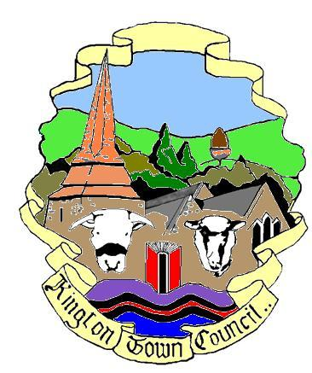
KINGTON TOWN COUNCIL
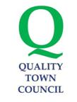

Kington Town Council, The Old Police Station,
Market Hall Street, Kington, HR5 3DP
Tel No. 01544 239098
Email clerk@kingtontowncouncil.gov.uk
Web Site www.kington.gov.uk

KINGTON TOWN COUNCIL
Covid Fund Grant Policy
Agreed by the Town Council at a meeting held on 1st February 2021

In recognition of the impact of Covid 19 on the people and businesses of Kington, Kington Town Council has established a Covid Fund which can be used for measures to support local people, organisations and businesses to mitigate the impact of Covid 19 during the pandemic and to help towards recovery of the town and its people after the Pandemic.

At the discretion of the Town Council, local organisations and groups can apply to the Town Council for funding from this fund which is aimed at measures to support the overall objective of the fund.

Guidance for applicants
The aim of Kington Town Council’s grant scheme is to promote community activity within the town, aimed at mitigating the effects of the Pandemic on the town, its people, organisations and businesses.
Grants are for local organisations benefiting local people: it is not possible to give a grant to a national organisation that does not have a locally-based group. Grants can be awarded to new and existing organisations.
Each application will be considered on its own merit and grants will not necessarily be available on an annual basis. There is a limited budget for grants and the total funding requested usually exceeds the total funds available. The maximum Grant that is usually awarded is £500 but applications can exceed this amount and may be agreed at the discretion of the Town Council.
Application packs are available from the Clerk at the above address: you can also request a pack by email or download one from the Council’s website www.kingtontowncouncil.gov.uk

Incorrect or incomplete forms will be returned to you for completion: please ask a Councillor or member of staff for help if you are unsure of anything.

Deadline for applications
Grants can be awarded throughout the year but are subject to funds being available.
What happens then?
The Grants Panel will meet to consider each application against KTC’s grants criteria and in the context of KTC’s grants budget. Successful applications will be submitted to full Council for ratification. Grant applicants may, if they wish, make a presentation to support their application or may be asked to attend to discuss their application with the Panel.
If an application is refused, the applicant will be given the reasons for refusal in writing.

Funding conditions
(Note: revised January 2021)

- Applications must be for projects that benefit the local community.
- Applications may be submitted at any time but please note can only be considered at a meeting of the Town Council so please ensure you allow sufficient time for your application to be received and considered before starting your project. Your application can be made on the standard application form for grants from the Town Council, available from the Town Council website or from the Town Clerk. Additional information, other than accounts and quotes, will not be considered unless that information is specifically requested by the Town Council
- An organisation is usually expected to submit one application for a grant in any financial year but more than one application might be considered in exceptional circumstances.
- Your organisation must submit a report to the Council on how the grant has been used within six months of the award. Failure to do so may result in future applications not being considered. Please also see condition 5 below.
- Any award is made on the basis that you agree to strive to comply with our Ethical and Environmental Policy, a copy of which is available on our website or on application from the Town Clerk. Your report (condition 4 above) should contain a statement confirming your compliance with that policy or stating why you have not been able to comply with the policy.
- Your organisation must be non-profit making
- Your organisation must demonstrate a clear need for financial support and show if any other fund raising has taken place
- Please supply a set of independently verified accounts for the previous financial year. For new or start up organisations, basic financial information must be provided which will include your budget for the current year.
- If your project is delivered at a cost which is less than originally anticipated, we reserve the right to request a reimbursement of funds not spent on the proposed project
- Any publicity or printed material in connection with your project should acknowledge the support of Kington Town Council
- Awards cannot be made to an individual but will be made to the organisation/community group.
NB: If you want to purchase any item costing more than £250 as part of your funding application, please submit at least two quotes for each item
The Town Council will not consider grant applications for:
Political or religious activities
Statutory bodies to fund core services
Sole benefit of individuals
A private profit-making / commercial organisation
Running costs – e.g. rent rates, electricity, etc
Projects that have already started – we do not make retrospective awards.
Projects which could reasonably be expected to secure finance by other means

Applicants are advised that lobbying of individual Councillors to support their application will invalidate their application.

PRIVACY STATEMENT
Kington Town Council is the Data Controller under data protection law and will use the information you provide on this form in order to consider whether or not to offer a grant to the organisation you represent. The legal basis for processing this data is your consent to do so. You can withdraw your consent at any time by notifying the Town Clerk at the address below. We will retain a copy of your information as provided on this form for a
period of 5 years from the date the grant is awarded.
Your information may be shared with our internal and external auditors if required to do so but will not be shared with anyone else other than within the Town Council as part of our normal financial processes.
Individuals have a number of rights under data protection law, including the right to request their information. You also have a right to make a complaint about our handling of your personal data to the Information Commissioner’s Office https://ico.org.uk/

Further information about the processing of your data can be found on our website at www.kingtontowncouncil.gov.uk.

