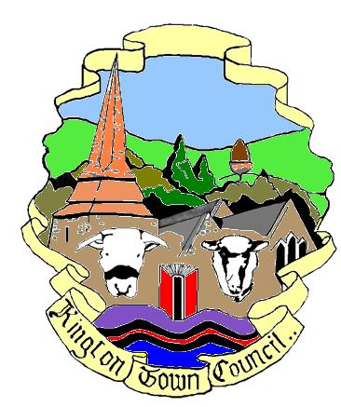 | Kington Town Council  Town Council Office, Old Police Station,  Market Hall Street, Kington, HR5 3DP  01544 239098 admin@kingtontowncouncil.gov.uk | 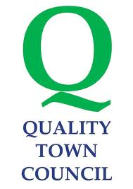

Application for a grant from Kington Town Council

Please fill in all sections as appropriate on behalf of your organisation. Should you wish to expand on an answer, please enclose additional information separately.

We only allow one project per application.

When completed please return this application form by email to: clerk@kingtontowncouncil.gov.uk or by post to The Town Clerk, Kington Town Council, Old Police Station, Market Hall Street, Kington HR5 3DP
Please make sure you sign and date the declaration at the end of this form.
Section one: your organisation
Organisation’s name?

Please tell us who your officers are

Your main contact
Name
Position or office held in organisation

Address

Phone: email

We are moving to BACS payments. Please provide us with details of the account to be credited, should your application be successful. (Write legibly please).

Bank | Account name | Sort code | Account number

s
Is your organisation a | Y/N | Charity / Company / VAT number
Registered charity
What is the charity number
Company limited by guarantee
If yes, what is the company number
Social enterprise
Community group
Other (tell us what)
Do you have a VAT number?

Have you had a grant before from Kington Town Council?
If yes, when?
If yes, did you submit an end of year report to comply with the grant conditions?*
*Please provide an end of year report with this application if you have not done so before

Section two: tell us about the project and what you want the funding for
(Please read the Guidance Notes for help in answering this)
How much are you requesting from Kington Town Council?

What will this pay for / how will you use this money?

Have you obtained or applied for funding from other funders for any items?

How will this project benefit Kington and its residents? Are there any particular groups of residents who will benefit, such as age ranges, abilities, or people in a specific area?

When do you plan to start and finish your project?
When your project has ended, what do you hope to have achieved?

What is the total cost of the project?

What are the itemised costs (for example, equipment, travel, stationary etc)?
Please list here.

Section three: Volunteers and ‘in kind’ support

What is your estimated number of volunteers likely to be involved in the project?

If none, why not?

Has anyone offered, or have you sought, any ‘in kind’ support for your project?
(for example, donations of free space or equipment)

Section four: What are the risks to this project?
What happens if you don’t get all the money you need for this project?

What will you do if Kington Town Council is unable to offer a grant?

Can you tell us anything else in support of your application?

Thank you for your application.
Please make sure that you have read the Guidance Notes and that your application
complies with the notes. Complete the Grant Checklist, enclose all the information required, and sign the Declaration below.

Declaration

I declare that the information given is correct and I agree to adhere to the conditions laid out in Kington Town Council’s Grants Policy.

On behalf of____________________________________________________
I accept the conditions in Kington Town Council’s Grants Policy

Signed_________________________________________________________

Dated_____________________

Please note:
Completion of this form does not necessarily mean that a grant application will be
successful in part or whole.

Incorrect or incomplete forms will be returned to you for completion: please ask a
Councillor or member of staff for help if you are unsure of anything.

Submission deadline: 4pm on Friday 22nd January 2021

