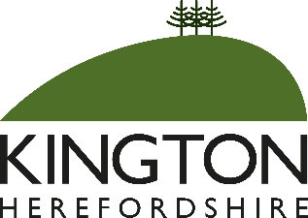

KINGTON ANNUAL TOWN MEETING 2022

To be held on Wednesday 18th May at 7.00pm
in the Old Police Station, Market Hall Street, Kington

AGENDA

- Welcome by the Mayor of Kington
- Presentation of Civic Awards for 2022
- Annual report from Kington Town Council
- Reports from organisations and groups working in Kington
- Matters raised by residents in attendance

By order of Kington Town Council
Cllr. David Redmayne
Mayor
Issued: 10.5.2022

The Annual Town Meeting is a meeting of residents offering an opportunity for everyone to celebrate the good work that individuals and groups within the town are undertaking and to raise matters of importance for discussion. Every resident of the town is welcome to attend. Refreshments will be served from 6.30pm onwards.

