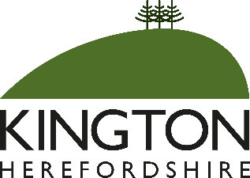

KINGTON ANNUAL TOWN MEETING 2025

To be held on Wednesday 21st May 2025 at 7.00pm
in the Burton Hotel, Mill Street, Kington

AGENDA

- Welcome by the Mayor of Kington
- Presentation of Civic Awards
- Annual report from Kington Town Council
- Reports from various organisations and groups working in Kington
- Feeding wild birds in public spaces – requested agenda item
- Matters raised by residents in attendance

By order of Kington Town Council
Mayor
Issued: 12.5.20265

The Annual Town Meeting is a meeting of residents offering an opportunity for everyone to celebrate the good work that individuals and groups within the town are undertaking and to raise matters of importance for discussion. Every resident of the town is welcome to attend.

