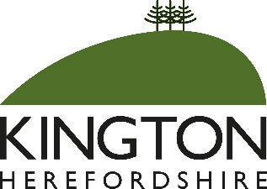

KINGTON TOWN COUNCIL
Community Grants

If you are a community group based in Kington and working for the benefit of local residents of Kington, you may be able to apply for a grant from Kington Town Council.

To apply your group needs to be a constituted group with its own bank account and we would usually grant an award for a one-off purchase or project rather than to cover running costs. Grant applications often exceed available funding so there is no guarantee of an award and we would normally only accept one application from each group during the year. The maximum award is usually £500.00.

For further information and an application form, please contact the Town Clerk whose contact details appear below. You can also download an application form from the town council website: www.kingtontowncouncil.gov.uk.

Your application must be received by the Town Council no later than Friday 28th August 2026.

