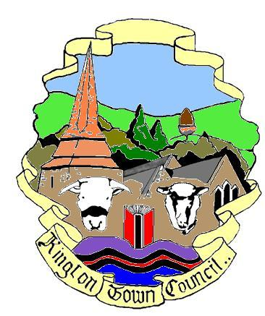 | Kington Town Council  Web Site: www.kingtontowncouncil.gov.uk  Email: clerk@kingtontowncouncil.gov.uk  Members of the Personnel Committee you are  hereby summoned to attend a meeting of the  Personnel Committee
Committee Members: Mayor Cllr R. Widdowson, Deputy Mayor Cllr. E. Banks.,
Deputy Mayor Cllr. M. Fitton, Cllrs. R. Banks, Cllr. R. MacCurrach, E. Rolls

To be held on Monday 26th July 2021 at 5.30pm
At The Old Police Station, Market Hall Street, Kington

Agenda

To elect a Chair of the Committee for the forthcoming year
To receive apologies, declarations of interest and requests for dispensation
To elect a Vice Chair of the Committee for the forthcoming year
To approve the Minutes of the meeting held on 12th April 2021
To consider the resolution that due to the confidential nature of the business of the next three agenda items, that members of the public be excluded from the following two agenda items in accordance with the provisions of the Public Bodies (Admission to Meetings) Act 1960 (3)
Recruitment of Assistant Clerk/Green Spaces Administrator and confirmation of recommendation to Full Council
Staff Appraisals
Kington Recreation Ground Trust staffing
Date and time of next meeting and items for the agenda

Issued by:
Liz Kelso
Clerk, Kington Town Council
21.07.2021

Members of the public are welcome to attend Committee Meetings of Kington Town Council and may, at the discretion of the Chairman speak on some agenda items. For further information on the procedure for speaking at Town Council Meetings, please speak to the Clerk at the address below

KINGTON TOWN COUNCIL
INFORMATION ON MEETINGS

Kington Town Council are delighted to return to face to face meetings for the first time since March 2020 as a result of the easing of Coronavirus restrictions. However, we must be aware that although infection rates are currently low, we must still ensure the health and safety of all those attending our meetings.

- Please observe social distancing and the wearing of masks at all times – unless you have a medical exemption - when inside the meeting venue, including during the meeting. We acknowledge that this may make it difficult to hear and be heard during the meeting but your safety and the safety of everyone attending is paramount.

- Please use the sanitiser provided when entering the building. Please follow any directional signage to a vacant seat and do not move the chairs provided. Please do not walk around the room once seated and if you leave the room during or at the end of the meeting, please observe any one way system. Doors and windows will remain open during the meeting.

- If you wish to refer to a copy of the agenda or meeting papers during the meeting please bring a copy with you as only limited supplies will be available. Do not share papers and take any papers home with you after the meeting.

- On entry you will be asked to give your name and details where you can be contacted over the next three weeks. Your details will be kept for track and trace purposes and may be handed over to the Public Health Department at Herefordshire Council if requested to do so. We will destroy your personal data if no such request is received after the 21 day period or as instructed by Herefordshire Council. By entering the meeting you will be deemed to have given permission for your personal data to be used for this purpose.

- Please consider taking a lateral flow Covid test before attending our meeting and only attend if the result is negative. This is a polite request and not obligatory but helps ensure your safety and that of others attending the same meeting.

- Please do not attend this meeting if you or a member of your household has symptoms of Coronavirus such as a new continuous cough, fever or change to your sense of taste or smell, whether or not you have had a recent Coronavirus test.

- Please do not attend the meeting if you or a member of your household has tested positive for Coronavirus within 14 days of the date of the meeting or you have been advised to self isolate as you have been in contact with someone who has tested positive for Coronavirus or have returned from a country where the UK government has indicated you should self isolate on return to the UK.

