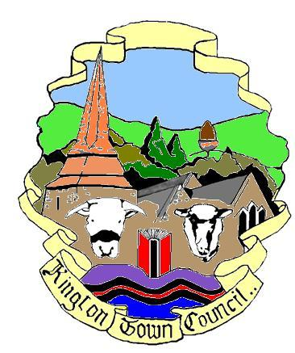 | Members of the Council you are  hereby summoned to attend a meeting of
Kington Town Council

to be held on Monday 12th July 2021 at 7.00 pm
at
The Oxford Arms, Duke Street, Kington
for the purpose of transacting the following business.
 | Agenda

1. To receive apologies for absence, declarations of interest and requests for dispensation
2. Town Councillor Vacancy: To note that the town council can now co-opt a town councillor to fill the current vacancy and consider applications, if any
3. Minutes: To confirm the Minutes of the meeting held on 14th June 2021
4. Public Participation:
- Matters raised by members of the public in attendance
- Ward Councillor report
- Police Report
  - Monthly report
  - Local Policing Community Charter
5. Mayor’s Report
6. Clerk’s Report
7. Financial Matters
- To approve payments as per the payment schedule
8. Planning Matters
9. Covid Memorial Benches: To note report from working group
10. To consider appointment of Kington Walking Hub as footpaths officer for the Town
11. To ratify the order for plants for Kington in Bloom for this year in accordance with the agreed budget of £800.00
12. To consider initial report from municipal gym task and finish group
13. To consider proposal to support the Queen’s Green Canopy by acquiring and planting trees this autumn
14. Date and time of next meeting and items for the agenda for the next meeting

Issued by: Liz Kelso PSLCC
Clerk, Kington Town Council
Email: clerk@kingtontowncouncil.gov.uk, Tel: 01544 239 098 or 07483 914 485
Issued: 8.6.2021

KINGTON TOWN COUNCIL
INFORMATION ON MEETINGS

Kington Town Council are delighted to return to face to face meetings since 2020 following the easing of Coronavirus restrictions. However, we must be aware that although infection rates are currently low, we must still ensure the health and safety of all those attending our meetings and must comply with new restrictions and rules.

- Please note that the meeting will be held at the Oxford Arms as our usual meeting room is too small to allow social distancing for Members of the Council, staff and members of the public. The Oxford Arms will not be open for business on the day of the meeting.

- You must observe social distancing and the wearing of masks at all times – unless you have a medical exemption - when inside the meeting venue, including during the meeting. We acknowledge that this may make it difficult to hear and be heard during the meeting but your safety and the safety of everyone attending is paramount.

- Please use the sanitiser provided when entering the building. Please follow any directional signage to a vacant seat and do not move the chairs provided. Please do not walk around the room once seated and if you leave the room during or at the end of the meeting, please observe any one way system. Doors and windows will remain open during the meeting.

- If you wish to refer to a copy of the agenda or meeting papers during the meeting please bring a copy with you as only limited supplies will be available. Do not share papers and take any papers home with you after the meeting.

- Apologies, but we are currently unable to offer refreshments.

- On entry you will be asked to give your name and details where you can be contacted over the next three weeks. Your details will be kept for track and trace purposes and may be handed over to the Public Health Department at Herefordshire Council if requested to do so. We will destroy your personal data if no such request is received after the 21 day period or as instructed by Herefordshire Council. By entering the meeting you will be deemed to have given permission for your personal data to be used for this purpose.

- Please do not attend this meeting if you or a member of your household has symptoms of Coronavirus such as a new continuous cough, fever or change to your sense of taste or smell, whether or not you have had a recent Coronavirus test.

- Please do not attend the meeting if you or a member of your household has tested positive for Coronavirus within 14 days of the date of the meeting or you have been advised to self isolate as you have been in contact with someone who has tested positive for Coronavirus or have returned from a country where the UK government has indicated you should self isolate on return to the UK.

- Entry to the meeting room may be refused once the maximum capacity of the room has been reached.

