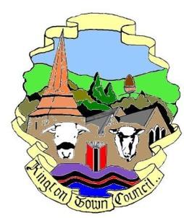 | Kington Town Council  Members of the Environment Committee of Kington Town Council  you are hereby summoned to attend a meeting of
The Environment Committee

On Monday 19th July 2021 at 6.30 pm or on conclusion of the
Planning Committee meeting, whichever is later
At
The Old Police Station, Market Hall Street, Kington

Committee Members: Mayor R. Widdowson, Deputy Mayor Cllr. E. Banks, Deputy Mayor Cllr. M. Fitton, Cllrs T. Bounds, J. Cooke, J. Dennis, P. Edwards, J. Gardner, R. MacCurrach, D. Redmayne and I. Spencer

 | Agenda
1. To elect a Committee Chair for the forthcoming year
2. To receive apologies, declarations of interest and requests for dispensation
3. To elect a Committee Vice Chair for the forthcoming year
4. To approve the Minutes of the meeting held on 15th March 2021
5. To consider update from the Climate Emergency Working Party
6. Standing items for discussion
6.1 Health & Safety
6.2 Town Centre
6.3 Kington in Bloom
6.4 Allotments
6.5 Recycling
6.6 Churchyard
6.7 Community Energy
6.8 Economic Development
6.9 War Memorial
6.10 Trees
6.11 KLEEN
7. Items for the next agenda
Issued on 12.7.2021 by:
Liz Kelso
Clerk, Kington Town Council
The Old Police Station, Market Hall Street, Kington HR5 3DP
Tel: 01544 239 098 Email: clerk@kingtontowncouncil.gov.uk

