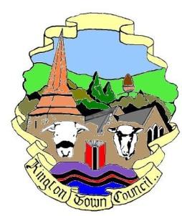 | Kington Town Council  Members of the Environment Committee of Kington Town Council  you are hereby summoned to attend a meeting of | 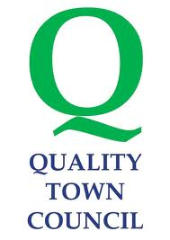
The Environment Committee

On Monday 15th November 2021 at 6.30 pm or on conclusion of the
Planning Committee meeting, whichever is later
At
The Old Police Station, Market Hall Street, Kington

Committee Members: Mayor R. Widdowson, Deputy Mayor Cllr. E. Banks, Deputy Mayor Cllr. M. Fitton, Cllrs T. Bounds, J. Cooke, P. Edwards, J. Gardner, R. MacCurrach, D. Redmayne and I. Spencer

 | Agenda
1. To receive apologies, declarations of interest and requests for dispensation
2. To approve the Minutes of the meeting held on 20th September 2021
3. To consider update from the Climate Emergency Working Party
4. To note report from the working party to consider light pollution
5. To note report from the working party formed to consider Community resilience
6. Flood risks in Kington
7. Standing items for discussion
7.1 Health & Safety
7.2 Town Centre
7.3 Kington in Bloom
7.4 Allotments
7.5 Recycling
7.6 Churchyard
7.7 Community Energy
7.8 Economic Development
7.9 Footpaths
7.10 War Memorial
7.11 Trees: Queen’s Green Canopy
7.10 KLEEN
8. Date of next meeting and Items for the next agenda

Issued on 08.11.2021 by:
Liz Kelso
Clerk, Kington Town Council
The Old Police Station, Market Hall Street, Kington HR5 3DP
Tel: 01544 239 098 Email: clerk@kingtontowncouncil.gov.uk

