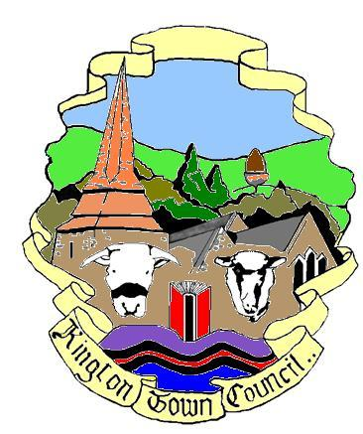 | Members of the Council you are  hereby summoned to attend a meeting of
Kington Town Council

to be held on Monday 1st November 2021 at 7.00 pm
at
The Oxford Arms, Duke Street, Kington
for the purpose of transacting the following business.
 | Agenda

1. To receive apologies for absence, declarations of interest and requests for dispensation
2. Minutes:
- To confirm the minutes of the meeting held on 4th October 2021
- To confirm the minutes of the meeting held on 18th October 2021
3. Town Councillor Vacancy: To co-opt a Town Councillor to fill the current vacancy
4. Public Participation:
- Police Report
- Matters raised by members of the public in attendance
- Ward Councillor report
5. Mayor’s Report
6. Report from Councillors on external meetings attended or to be attended
7. Clerk’s Report
8. Financial Matters
- To approve payments totalling £2,059.12 (+VAT) as per the payment schedule
- To elect a financial examiner for the Town Council
- To consider and agree recommendation from the Finance & General Purposes Committee for the award of Community Grants
- To consider request for a grant from Kington Hockey Club
- To consider and confirm projects using funding through the Welcome Back Fund and agree task and finish group to carry these forward
- To consider and confirm projects using funding through the Great Places to Visit Fund and agree task and finish group to carry these forward
- Update on Festival Grant Fund application
- Update on Green Spaces Grant application
- To note requests, if any, from Kington Recreation Ground Trust for expenditure against allocated grant budget
9. Christmas Decorations: Update

10. Planning Matters:
To consider the following planning application:
Ref: 213793
Site: Flat 10, White House, 20 Church Street, Kington
Dev: Crown reduction of a cherry tree which is impacting on a wall
11. Highway Matters: To consider proposal to address concerns on highway safety along the bypass
12. Queen’s Platinum Jubilee:
- To note report from working party to consider preparations for Queen’s Platinum Jubilee celebrations for June 2022
- To consider proposals for tree planting for Queen’s Green Canopy
13. Armed Forces Covenant: preliminary discussion
14. To consider quotation for repairs to lights around the War Memorial
15. Reports from Committees:
- Finance & General Purposes Committee held 11th October 2021
- Planning Committee held 18th October 2021
- Services Committee held 18th October 2021
16. Items for the next agenda
17. Date and time of next meeting

Issued by: Liz Kelso PSLCC
Clerk, Kington Town Council
Email: clerk@kingtontowncouncil.gov.uk, Tel: 01544 239 098 or 07483 914 485
Issued: 27.10.2021

KINGTON TOWN COUNCIL
INFORMATION ON MEETINGS

Kington Town Council are delighted to return to face to face meetings since 2020 following the easing of Coronavirus restrictions. However, we must be aware that infection rates remain high and we must ensure the health and safety of all those attending our meetings.

- Please note that the meeting will be held at the Oxford Arms as our usual meeting room is considered too small to allow social distancing for Members of the Council, staff and members of the public. The Oxford Arms will not be open for business on the day of the meeting.

- We would ask you to observe social distancing and the wearing of masks – unless you have a medical exemption - when inside the meeting venue. We acknowledge that this may make it difficult to hear and be heard during the meeting but your safety and the safety of everyone attending is paramount. If at all possible, please take a lateral flow test before attending this meeting.

- Please use the sanitiser provided when entering the building. Please follow any directional signage to a vacant seat and do not move the chairs provided. Please do not walk around the room once seated and if you leave the room during or at the end of the meeting, please observe any one way system. Doors and windows will remain open during the meeting.

- If you wish to refer to a copy of the agenda or meeting papers during the meeting please bring a copy with you as only limited supplies will be available. Do not share papers and take any papers home with you after the meeting.

- Apologies, but we are currently unable to offer refreshments.

- On entry you will be asked to give your name and details where you can be contacted over the next three weeks. Your details will be kept for track and trace purposes and may be handed over to the Public Health Department at Herefordshire Council if requested to do so. We will destroy your personal data if no such request is received after the 21 day period or as instructed by Herefordshire Council. By entering the meeting you will be deemed to have given permission for your personal data to be used for this purpose.

- Please do not attend this meeting if you or a member of your household has symptoms of Coronavirus such as a new continuous cough, fever or change to your sense of taste or smell, whether or not you have had a recent Coronavirus test.

- Please do not attend the meeting if you or a member of your household has tested positive for Coronavirus within 14 days of the date of the meeting or you have been advised to self isolate as you have been in contact with someone who has tested positive for Coronavirus or have returned from a country where the UK government has indicated you should self isolate on return to the UK.

- Entry to the meeting room may be refused once the maximum capacity of the room has been reached.

