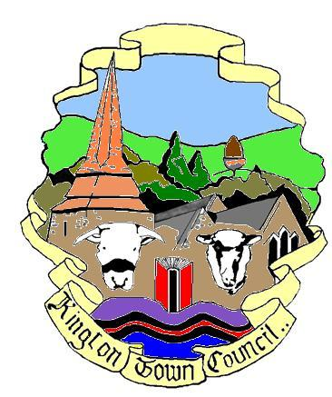 | Members of the Council you are  hereby summoned to attend an additional ordinary meeting of
Kington Town Council

to be held on Monday 17th January 2022 at 5.30 pm
at
The Old Police Station, Market Hall Street, Kington
for the purpose of transacting the following business.
 | Agenda

1. To receive apologies for absence, declarations of interest and requests for dispensation
2. Consider recommendation from the Festivals Working Group to commission a logo to be used for marketing purposes for town Events, Festivals and other activities to promote the town and attract visitors and shoppers

Issued by:
Liz Kelso, Town Clerk
Kington Town Council
Email: clerk@kingtontowncouncil.gov.uk, Tel: 01544 239 098 or 07483 914 485
Issued: 11.01.2022

KINGTON TOWN COUNCIL
INFORMATION ON MEETINGS

Kington Town Council are delighted to return to face to face meetings since 2020 following the easing of Coronavirus restrictions. However, we must be aware that infection rates are high and we must ensure the health and safety of all those attending our meetings.

- You are requested to observe social distancing and the wearing of masks at all times – unless you have a medical exemption - when inside the meeting venue, including during the meeting. We acknowledge that this may make it difficult to hear and be heard during the meeting but your safety and the safety of everyone attending is paramount.

- Please use the sanitiser provided when entering the building. Please follow any directional signage to a vacant seat and do not move the chairs provided. Please do not walk around the room once seated and if you leave the room during or at the end of the meeting, please observe any one-way system. Doors and windows will remain open during the meeting.

- If you wish to refer to a copy of the agenda or meeting papers during the meeting please bring a copy with you as only limited supplies will be available. Do not share papers and take any papers home with you after the meeting.

- On entry you will be asked to give your name and details where you can be contacted over the next three weeks. Your details will be kept for track and trace purposes and may be handed over to the Public Health Department at Herefordshire Council if requested to do so. We will destroy your personal data if no such request is received after the 21 day period or as instructed by Herefordshire Council. By entering the meeting you will be deemed to have given permission for your personal data to be used for this purpose.

- If at all possible, please take a lateral flow test before attending the meeting and do not attend if the test is positive or inconclusive

- Please do not attend this meeting if you or a member of your household has symptoms of Coronavirus such as a new continuous cough, fever or change to your sense of taste or smell, whether or not you have had a recent Coronavirus test.

- Please do not attend the meeting if you or a member of your household has tested positive for Coronavirus within 10 days of the date of the meeting or you have been advised to self isolate as you have been in contact with someone who has tested positive for Coronavirus or have returned from a country where the UK government has indicated you should self isolate on return to the UK.

- Entry to the meeting room may be refused once the maximum capacity of the room has been reached.

