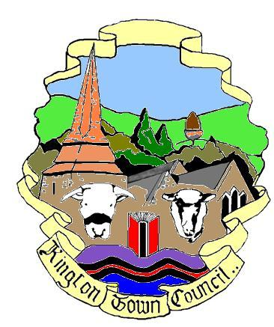 | Members of the Council you are  hereby summoned to attend a meeting of
Kington Town Council

to be held on Monday 7th March 2022 at 7.00 pm
at
The Old Police Station, Market Hall Street, Kington
for the purpose of transacting the following business.
 | Agenda

1. To receive apologies for absence, declarations of interest and requests for dispensation
2. Minutes:
To confirm the minutes of the meeting held on 7th February 2022
3. Public Participation:
- Police Report
- Matters raised by members of the public in attendance
- Ward Councillor report
4. Mayor’s Report
5. Report from Councillors on external meetings attended or to be attended
6. Clerk’s Report
7. Financial Matters
- To approve payments as detailed on the payment schedule
- To consider recommendation from the finance and general purposes committee for the award of grants to Community Groups
- Welcome Back Fund:
  - Christmas Decorations Project
  - To note update on Marketing for Festivals Project
- Great Places to Visit Fund:
  - To note update on shop front grant scheme and to authorise the award of additional grants, as recommended by the shop front grant panel working group
  - In recognition of the need for expediency in awarding contracts in order to benefit from external funding availability in both cases and having regard to attempts to obtain comparative quotations for the work/projects envisaged, to consider and if thought fit to agree to waive financial regulation 11.1(h) for the following two contracts to be funded through the Great Places to Visit Fund.
  - To consider quotations for planters to be purchased, installed and maintained under the Kington in Bloom project
  - To consider quotations for the Public Rights of Way signage/map project

- Green Spaces Grant:
  - In recognition of the need for expediency in awarding contracts in order to benefit from external funding availability and having regard to attempts to obtain comparative quotations for the work/projects envisaged, to consider and if thought fit to agree to waive financial regulation 11.1(h) for the following contract to be funded through the Herefordshire Green Spaces Fund.
- To consider quotations for Outdoor Gym Equipment to be installed in Kington Recreation Ground
f) To agree recommendation of the Finance and General Purposes Committee that Iain Selkirk FCA be re-appointed Internal Auditor for the Town Council for a further year
8. To consider and agree brief for Transport study as provided by Herefordshire Council
9. To note update on Herefordshire Council’s proposals for car park charges in Kington
10. To consider correspondence on Community Asset Transfers and agree a way forward
11. To consider whether to continue with purchase of two pages in MidBorder News for a further year at a cost of £250.00 per issue
12. To consider date, venue and format for the Annual Town Meeting 2022
13. Queen’s Platinum Jubilee:
To note update on plans for Queen’s Platinum Jubilee
14. To approve amendment to membership of planning committee and personnel committee
15. To note Herefordshire Council consultation on Environmental Building Standards and to delegate authority to Planning Committee to draft response on behalf of the Town Council
16. Reports from Committees:
- Planning Committee held 21st February 2022
- Services Committee held 21st February 2022
- Personnel Committee held 21st February 2022
- Finance and General Purposes Committee held 28th February 2022
17. Date and time of next meeting and items for the agenda

Issued by: Liz Kelso PSLCC
Clerk, Kington Town Council
Email: clerk@kingtontowncouncil.gov.uk, Tel: 01544 239 098 or 07483 914 485
Issued: 3.3.2022

Members of the public are welcome to attend meetings of Kington Town Council and may, at the discretion of the Chair, speak on some agenda items. In the interests of health and safety for Councillors, staff members and other meeting attendees, please do not attend this meeting if you are unwell, whether or not you have tested positive for Coronavirus.

