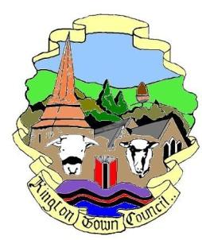 | Kington Town Council  Email: clerk@kingtontowncouncil.gov.uk  Web site: www.kingtontowncouncil.gov.uk
The Planning Committee
On Monday 21st March 2022 at 6.00pm
At
The Old Police Station, Market Hall Street, Kington

for the purpose of transacting the following business
Committee Members: Cllrs. E. Banks, T. Bounds, J. Cooke, P. Edwards, M. Fitton, F. Hawkins, E. Rolls, I. Spencer, R. Warne &
R. Widdowson

Agenda

1. To receive apologies for absence, declarations of interest, as required, and requests for dispensation
2. To confirm the Minutes of the meeting held on 21st February 2022
3. To consider the following planning application:
- Ref: 220332
Site: Kington Museum, Mill Street, Kington
Dev: Proposed replacement door and window units to provide double glazing
4. To note planning decisions by Herefordshire Council since last meeting
5. To note report regarding possible planning enforcement action
6. To consider response to Herefordshire Council’s draft Environmental Building Standards document
7. Update on Herefordshire Local Plan Spatial Options Consultation response
8. Date of next meeting and items for the agenda.

Issued on 16.3.2022 by
Liz Kelso
Clerk, Kington Town Council
The Old Police Station, Market Hall Street, Kington, HR5 3DP
Tel: 01544 239 098 or Mob: 07483 914 485
Email: clerk@kingtontowncouncil.gov.uk

