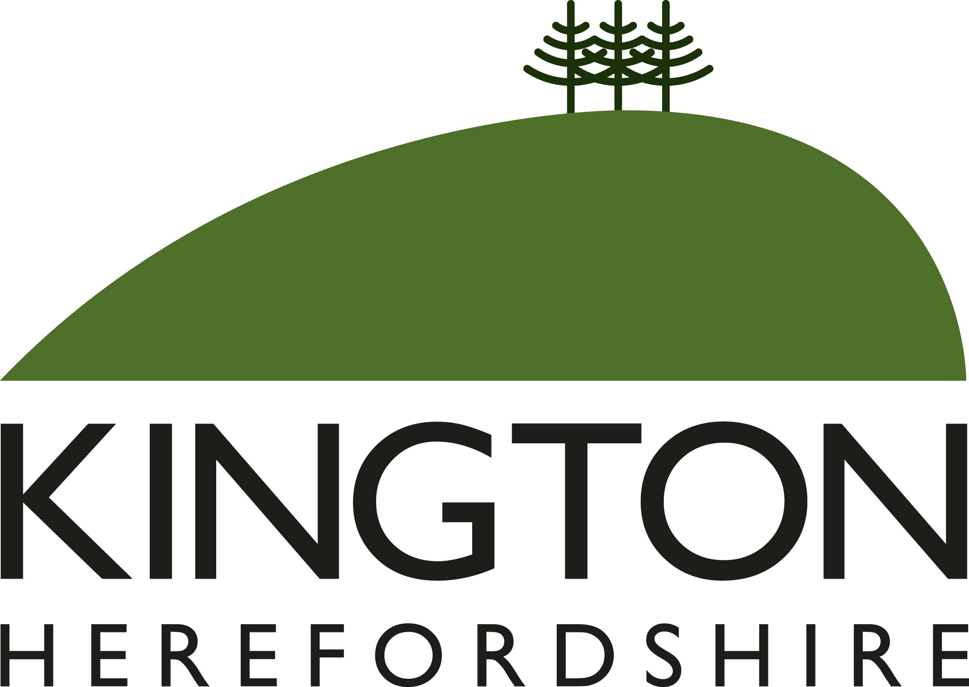 | Members of the Council you are  hereby summoned to attend a meeting of
Kington Town Council

to be held on Monday 6th June 2022 at 7.00 pm
at
The Old Police Station, Market Hall Street, Kington
for the purpose of transacting the following business.
 | Agenda

1. To receive apologies for absence, declarations of interest and requests for dispensation
2. Minutes: To confirm the minutes of the meeting held on 9th May 2022
3. Public Participation:
- Police Report
- Matters raised by members of the public in attendance
- Ward Councillor report
4. Mayor’s Report
5. Clerk’s Report
6. Financial Matters
- To approve payments as detailed on the payment schedule
- To consider recommendation from the shop front grant scheme working party for the payment of grants as per attached list
- Great Places to Visit Fund: Update on funded projects progress
- To note the report of the Internal auditor for the year ended 31st March 2022
- To note the receipts and payments account for the year ended 31st March 2022
- To consider and agree the Annual Governance Statement for the year ended 31st March 2022
- To consider and agree the Annual Accounting Statement for the year ended 31st March 2022
- To note arrangements for the exercise of electors rights for year ended 31.3.2022
7. To note report on Christmas lights review and agree further action
8. To consider offer of transfer of ownership of the statue by local artist Rachel Ricketts entitled “Fly the Walking Dog of Kington” to the Town Council
9. To consider the proposal for the use of s106 monies for a zebra crossing opposite the primary school in Kington

10. Reports from Committees:
- Personnel Committee held on 16th May 2022
- Planning Committee held on 16th May 2022
- To note inquorate Environment Committee scheduled for 16th May 2022
11. Information only item (no discussion): Reports from Councillors
12. Date and time of next meeting and items for the agenda

Issued by: Liz Kelso
Clerk, Kington Town Council
Email: clerk@kingtontowncouncil.gov.uk, Tel: 01544 239 098 or 07483 914 485
Issued: 30.3.2022

Members of the public are welcome to attend meetings of Kington Town Council and may, at the discretion of the Chair, speak on some agenda items. In the interests of health and safety for Councillors, staff members and other meeting attendees, please do not attend this meeting if you are unwell, whether or not you have tested positive for Coronavirus.

