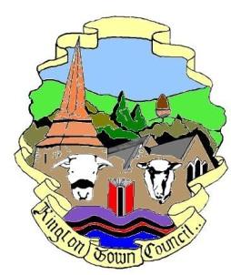 | Kington Town Council
Services Committee
Members of the Services Committee you are hereby summoned to attend
a meeting of the Services Committee at
The Old Police Station, Market Hall Street, Kington, on
Monday 20th June at 6.30pm or on completion of the F&GP Committee, whichever is later
for the purpose of discussing the following business.
Committee Members:
Cllrs. E. Banks, R. Banks, T. Bounds, J. Gardner, F. Hawkins, P. Sell,
D. Redmayne, & R. Widdowson

Agenda

To elect a Chair of the Committee until May 2023
To note apologies, declarations of interest and requests for dispensation
To elect a Vice Chair of the Committee Until May 2023
To agree Minutes of the meeting held on 18th October 2021
To consider the need for increased bus links and services and what options are available to the council
To discuss the following standing items:
- Buildings currently occupied by the Town Council and such other buildings that can be determined as Community Assets
- Provision of public conveniences
- Provision for young people
- Tourism and Tourist Information Centre
- Arts, culture and museum provision
- Social care, support services and information and advice provision
- Health provision and care
- The Leisure Centre
- LHS Foundation
- Educational provision
- Markets
Date of next meeting and items for the agenda

Issued by
Liz Kelso
Town Clerk
On 7.12.2022

