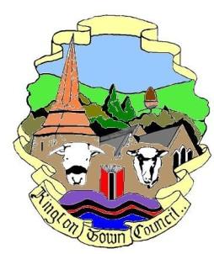 | Kington Town Council  Tuesday 16th January 2017  Members of the Environment Committee of Kington Town Council  you are hereby summoned to attend a meeting of
The Environment Committee

On Monday 23rd January 2017 at 7.00 pm

or upon the rising of the Planning Committee
whichever is the later

In The Old Police Station, Market Hall Street, Kington, HR5 3DP
for the purpose of transacting the following business.
Signed | 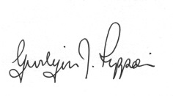Gwilym J. Rippon Cert He CEG, MILCM  Clerk to Kington Town Council
Committee Members:

Mayor Cllr. Banks, Deputy Mayor Cllr. Widdowson, Deputy Mayor Cllr. Fitton, Cllr. Bounds, Laurie, MacCurrach, Prior, Rolls &
Wood-Johnson
Agenda

To accept apologies for absence through the Clerk
To make any declaration of interest in items on the agenda
To receive any written dispensations
To confirm the minutes of the Environment Committee meeting 21st November 2016 (previously circulated)
Update in relation to the Churchyard wall
The following are standing items for discussion: -
  - Community/Neighbourhood plan
  - Health and Safety
  - Town Centre
  - Kington in Bloom
  - Allotments
  - Recycling
  - Churchyard
  - Community Energy
  - Economic development
  - Lengthsman
  - War Memorial,
  - Quarry Liaison
  - Tree Warden
  - KLEEN
  - Kington in Bloom
Items for the next agenda

