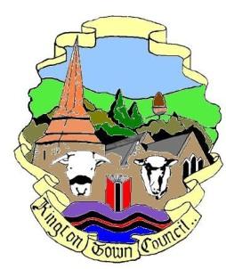 | Kington Town Council  Members of the Environment Committee of Kington Town Council  you are hereby summoned to attend a meeting of | 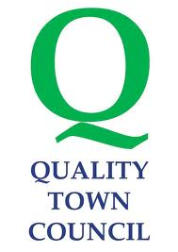
The Environment Committee

On Monday 17th July 2017 at 6.30 pm

In The Old Police Station, Market Hall Street, Kington, HR5 3DP
for the purpose of transacting the following business.
 | Agenda

1. To confirm election of the Chair
2. To receive apologies
3. To receive declarations of interest
4. To consider requests for dispensation
5. Standing items for discussion
5.1 Neighbourhood Plan
5.2 Health & Safety
5.3 Town Centre
5.4 Kington in Bloom
5.5 Allotments
5.6 Recycling
5.7 Churchyard
5.8 Community Energy
5.9 Economic Development
5.10 Lengthsman
5.11 War Memorial
5.12 Quarry Liaison
5.13 Tree Warden
5.14 KLEEN
6. Items for the next agenda

Issued on 10.7.2017 by:
Liz Kelso
Clerk, Kington Town Council
The Old Police Station, Market Hall Street, Kington HR5 3DP
Tel: 01544 239 098
Email: clerk@kingtontowncouncil.gov.uk

