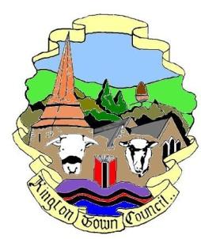 | Kington Town Council  Tuesday 14th February 2017  Members of the Environment Committee of Kington Town Council  you are hereby summoned to attend a meeting of
The Services Committee

On Monday 20th February 2017 6.30 pm

In The Old Police Station, Market Hall Street, Kington HR5 3DP
for the purpose of transacting the following business.
Signed | 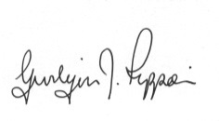 Gwilym J. Rippon Cert He CEG, MILCM
Clerk to Kington Town Council

Committee Members:
Mayor Cllr. Banks, Deputy Mayor Cllr. Widdowson,
Deputy Mayor Cllr Fitton, Cllrs. Bound, Forrester, Hawkins, Prior and Wood - Johnson

Agenda

 | To accept apologies for absence through the Clerk
 | To confirm and sign the minutes as a true record of the meeting held Monday 17th October 2016 (previously circulated)
 | To make any declaration of interest in items on the agenda
 | To receive any written dispensations
- - | To discuss the following: -  - Buildings currently occupied by the Town Council and such other buildings that can be determined as Community Assets.  - Provision of public conveniences  - Youth centre and provision for young people  - Play area provision  - Tourism and Tourist Information Centre  - Arts, culture and museum provision  - Social care, support services and information and advice provision  - Health provision and care  - The leisure centre  - LHS Foundation  - Educational provision  - Markets
 | Items for the next agenda

