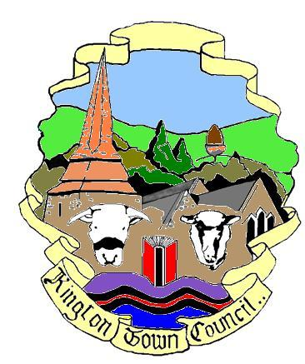 | Kington Town Council  Monday 10th April 2017  Members of the Council you are  hereby summoned to attend a meeting of | 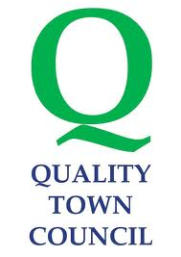
Kington Town Council

and will be held on Tuesday 18th April 2017 at 7.15 pm

In The Old Police Station, Market Hall Street, Kington HR5 3DP
for the purpose of transacting the following business.
Signed | 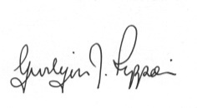 Gwilym J. Rippon Cert He CEG, MILCM
Clerk to Kington Town Council

Agenda
To accept apologies for absence through the clerk
To make declarations of interest in items on the agenda
To consider any written dispensations received
To receive an update from the Neighbourhood Plan
*To discuss and decide on a recipient for the Civic award

* Due to the confidential nature of the business of this agenda item, under the Public Bodies (Admission to Meetings) Act 1960 (3) it is proposed to put forward a motion to exclude members of the public during discussion of this agenda item.

