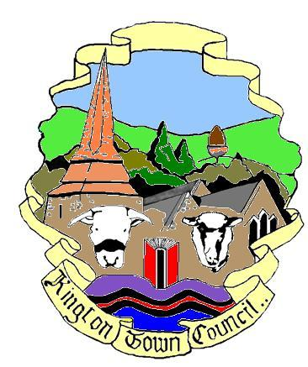 | Kington Town Council  Monday 8th May 2017  Members of the Council you are  hereby summoned to attend a meeting of
Kington Town Council

and will be held on Monday 15thj May 2017 at 6.45 pm
Or upon the rising of the Environment Committee

In The Old Police Station, Market Hall Street, Kington HR5 3DP
for the purpose of transacting the following business.
Signed | 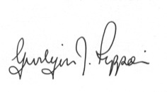 Gwilym J. Rippon Cert He CEG, MILCM
Clerk to Kington Town Council

Agenda
To accept apologies for absence through the clerk
To make declarations of interest in items on the agenda
To consider any written dispensations received
To discuss and decide on the draft Neighbourhood Plan

