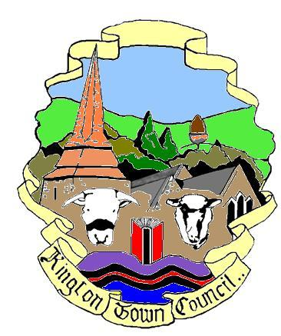 | Kington Town Council  Monday 26th June 2017  Members of the Council you are  hereby summoned to attend a meeting of
Kington Town Council

and will be held on Monday 3rd July 2017 at 7.00 pm

In The Old Police Station, Market Hall Street, Kington HR5 3DP
for the purpose of transacting the following business.
Signed | 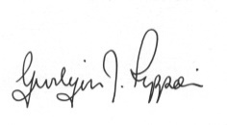 Gwilym J. Rippon Cert He CEG, MILCM
Clerk to Kington Town Council

Agenda

To accept apologies for absence through the clerk
To make declarations of interest in items on the agenda
To consider any written dispensations received
To confirm and sign the minutes as a true record of the meetings held on Monday 5th June 2017
- To receive the Police report
- To receive the Ward Councillor’s report
- To receive questions from members of the public
To receive the Mayor’s report
To receive the Clerk’s report (included)
To discuss and decide on the Dog Control consultation
To discuss and decide the provision CCTV (for dog fouling)
Proposed Independent Health Commission on the Redesign of Community Healthcare Services in Kington Locality
Finance
- To agree invoices for payment
As per schedule of payments (included)
Planning
To discuss the following planning application
P171775/O
Application for the Construction of 5 no. self build dwellings together with associated access, carparking and landscaping at Land at Newburn Farm adjacent to Kingswood Road Kington
Update on the NDP
Update on Lady Hawkins’ six form
Reports from Committees Chairs.
To note any meetings attended by Councillors.
To receive questions from Councillors
To present items for inclusion on the next agenda.
To consider any written dispensations received
Items for inclusion on the next agenda should be submitted to the clerk eight days prior to the meeting.

Gwilym J.Rippon, Kington Town Council Clerk
Town Council Office, Old Police Station, Market Hall Street, St, Kington, HR5 3DP
Telephone 01544 239098 email clerk@kingtontowncouncilgov.uk

