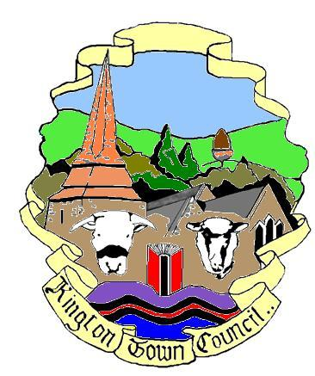 | Kington Town Council  Members of the Council you are  hereby summoned to attend a meeting of | 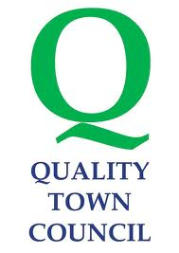
Kington Town Council

to be held on Monday 8th January 2018 at 7.00 pm

at The Old Police Station, Market Hall Street, Kington HR5 3DP
for the purpose of transacting the following business.
 | Agenda
1. To receive apologies for absence
2. To receive declarations of interest and requests for dispensation
3. To confirm and sign the Minutes of the meeting held on 4th December 2018
4. Public participation:
a. To receive the police report
b. To receive the Ward Councillor’s report
c. Matters raised by members of the public
5. Information item: To receive the Mayor’s Report
6. Information item: To receive the Clerk’s Report
7. Finance Matters
(a) To agree payments, as attached
(b) To agree budget for 2018-9
(c) To agree precept request for 2018-9
(d) To agree renewal of Council insurance portfolio
8. To receive update on Neighbourhood Development Plan
9. To amend Committee appointments
10. To consider work required on churchyard trees
11. To consider proposal to join pilot scheme for footpath maintenance
12. Community Champions Awards
13. Information item: To note reports from Committees
14. Information item: Reports from Councillors on meetings attended.
15. To confirm future meeting dates
16. Items for inclusion on next agenda
17. Date of next meeting

Issued on 03.01.2018 by:
Liz Kelso
Clerk, Kington Town Council
Email: clerk@kingtontowncouncil.gov.uk
Tel: 01544 239 098

Members of the public are welcome to attend meetings of the Town Council and may, at the discretion of the Chairman, speak on some agenda items. For further information on council procedures please speak to the clerk

