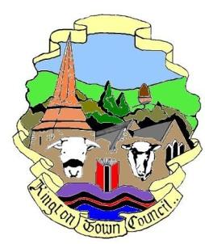 | Kington Town Council  Monday 10th April 2017  Members of the Services Committee of Kington Town Council  you are hereby summoned to attend a meeting of | 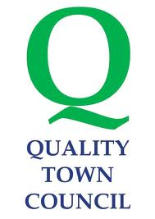
The Services Committee

On Tuesday 18th April 2017 6.30 pm

In The Old Police Station, Market Hall Street, Kington HR5 3DP
for the purpose of transacting the following business.
Signed | 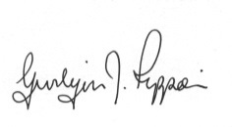 Gwilym J. Rippon Cert He CEG, MILCM
Clerk to Kington Town Council

Committee Members:
Mayor Cllr. Banks, Deputy Mayor Cllr. Widdowson,
Deputy Mayor Cllr Fitton, Cllrs. Bound, Forrester, Hawkins, Prior and Wood - Johnson

Agenda

 | To accept apologies for absence through the Clerk
 | To confirm and sign the minutes as a true record of the meeting held Monday 20th February 2017 (previously circulated)
 | To make any declaration of interest in items on the agenda
 | To receive any written dispensations
- - | To discuss the following: -  - Buildings currently occupied by the Town Council and such other buildings that can be determined as Community Assets.  - Provision of public conveniences  - Youth centre and provision for young people  - Play area provision  - Tourism and Tourist Information Centre  - Arts, culture and museum provision  - Social care, support services and information and advice provision  - Health provision and care  - The leisure centre  - LHS Foundation  - Educational provision  - Markets
 | Items for the next agenda

