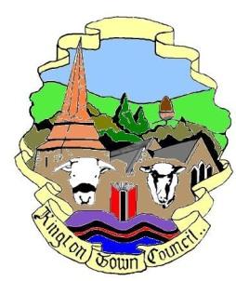 | Kington Town Council  Monday 12th June 2017  Members of the Environment Committee of Kington Town Council  you are hereby summoned to attend a meeting of
The Services Committee

On Monday 19th June 2017 7.15 pm

or upon the rising of the Planning Committee
whichever is the later

In The Old Police Station, Market Hall Street, Kington HR5 3DP
for the purpose of transacting the following business.
Signed | 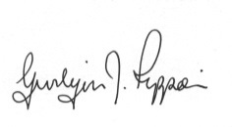 Gwilym J. Rippon Cert He CEG, MILCM
Clerk to Kington Town Council

Committee Members:
Mayor Cllr Fitton., Deputy Mayor Cllr. Widdowson,
Deputy Mayor Cllr Forrester, Cllrs. Bound, Hawkins, Laurie, Banks, Dennis, Prior and Wood - Johnson

Agenda

To elect a Chair
To accept apologies for absence through the Clerk
To elect a Vice-Chair
To confirm and sign the minutes as a true record of the meeting held Monday 18th April 2017 (previously circulated)
To make any declaration of interest in items on the agenda
To receive any written dispensations
To discuss the following: -

  - Buildings currently occupied by the Town Council and such other buildings that can be determined as Community Assets.
  - Provision of public conveniences
  - Youth centre and provision for young people
  - Play area provision
  - Tourism and Tourist Information Centre
  - Arts, culture and museum provision
  - Social care, support services and information and advice provision
  - Health provision and care
  - The leisure centre
  - LHS Foundation
  - Educational provision
  - Markets
Items for the next agenda

