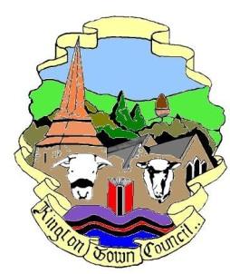 | Kington Town Council  Members of the Environment Committee of Kington Town Council  you are hereby summoned to attend an Extraordinary meeting of
The Environment Committee

On Tuesday 29th August 2017 at 6.30 pm
In The Old Police Station, Market Hall Street Kington, HR5 3DP
for the purpose of transacting the following business:

Committee members: Cllr. R. MacCurrach (Chair), Cllrs. J. Atkinson, E. Banks, T. Bounds, J. Dennis, M. Fitton, C. Forrester, W. Laurie, P. Prior, I Wood-Johnson
 | Agenda

1. Apologies

2. Declarations of Interest and requests for dispensation

3. To consider quotations received for the repairs to the Churchyard Wall and make recommendations to the Full Council for the award of the contract for these repairs

Issued on 23.8.2017 by:
R. MacCurrach
Chair, Environment Committee, Kington Town Council

Enquiries to:
Town Clerk, Kington Town Council
The Old Police Station, Market Hall Street, Kington HR5 3DP
Tel: 01544 239 098
Email: clerk@kingtontowncouncil.gov.uk

