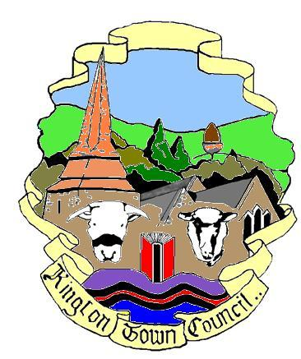 | Kington Town Council  Members of the Council you are  hereby summoned to attend a meeting of | 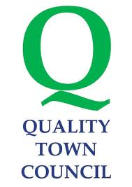
Kington Town Council

to be held on Monday 12th March 2018 at 7.00 pm

at The Old Police Station, Market Hall Street, Kington HR5 3DP
for the purpose of transacting the following business.
 | Agenda
1. To receive apologies for absence
2. To receive declarations of interest and requests for dispensation
3. To confirm and sign the Minutes of the meeting held on 8th January 2018
4. Public participation:
a. To receive the police report
b. To receive the Ward Councillor’s report
c. Matters raised by members of the public
5. Information item: To receive the Mayor’s Report
6. Information item: To receive the Clerk’s Report
7. Finance Matters
- To agree payments, as attached
- To consider the recommendations of the grants panel
- To consider the appointment of an internal auditor for the forthcoming financial year
8. To receive update on Neighbourhood Development Plan
9. To consider report on Health Commission findings
10. To consider the future of Kington in Bloom
11. Report on Herefordshire Great Places initiative
12. Ringing out for Peace – 11th November 2018
13. Update on proposals from the Dog Mess Working Party
14. To decide venue for Annual Town Meeting
15. To consider Herefordshire Council’s Stop the Drop Litter Pledge
16. To appoint a representative of the Town Council to the Lady Hawkins’ School Foundation
17. Update on defibrillator and proposal to purchase new pads
18. Planning Matters
To consider the following planning applications:

- Ref: 180549
Site: Kington Recreation Ground, Park View, Kington
Dev: Work on trees within a conservation area

- Ref: 180431
Site: Penrhos Farm, Lyonshall, Kington
Dev: Proposed installation of poly-tunnels to protect a new sweet cherry orchard and construction of an attenuation pond for surface water management

19. Herefordshire Council Review of Weight Limits for vehicles in Kington
20. Information item: To note reports from Committees
21. Information item: Reports from Councillors on meetings attended
22. Items for inclusion on next agenda
23. Date of next meeting

Issued on 26.02.2018 by:
Liz Kelso
Clerk, Kington Town Council
Email: clerk@kingtontowncouncil.gov.uk
Tel: 01544 239 098

Members of the public are welcome to attend meetings of the Town Council and may, at the discretion of the Chairman, speak on some agenda items. For further information on council procedures please speak to the clerk

