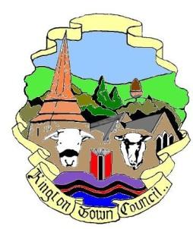 | Kington Town Council  Members of the Environment Committee of Kington Town Council  you are hereby summoned to attend a meeting of
The Environment Committee

On Monday 26th March 2018 at 7.00 pm or on conclusion of the
Planning Committee meeting

In The Old Police Station, Market Hall Street Kington, HR5 3DP
for the purpose of transacting the following business.

Committee Members: Cllrs. J. Atkinson, Mrs. E. Banks, T. Bounds, J. Dennis, M. Fitton
Mrs. C. Forrester, W. Laurie, R. MacCurrach, Mrs. P. Prior, Mrs. L. Rees, I. Wood-Johnson
 | Agenda

1. To receive apologies for absence
2. To receive declarations of interest and requests for dispensation
3. To approve the Minutes of the meeting held on 22nd January 2018
4. To consider request by resident for support for parking restrictions on Island Terrace
5. Highway matters
6. Standing items for discussion
6.1 Neighbourhood Plan
6.2 Health & Safety
6.3 Town Centre
6.4 Kington in Bloom
6.5 Allotments
6.6 Recycling
6.7 Churchyard
6.8 Community Energy
6.9 Economic Development
6.10 Footpaths Scheme
6.11 War Memorial
6.12 Quarry Liaison
6.13 Trees
6.14 KLEEN
7. Items for the next agenda

Issued on 12.3.2018 by:
Liz Kelso
Clerk, Kington Town Council
The Old Police Station, Market Hall Street, Kington HR5 3DP
Tel: 01544 239 098
Email: clerk@kingtontowncouncil.gov.uk

