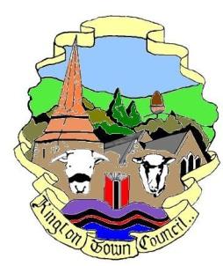 | Kington Town Council  Members of the Environment Committee of Kington Town Council  you are hereby summoned to attend a meeting of
The Environment Committee

On Monday 19th November 2018 at 6.30 pm or on completion of the planning committee

In The Old Police Station, Market Hall Street, Kington, HR5 3DP
for the purpose of transacting the following business.

Committee Members: Cllrs. J. Atkinson, Mrs. E. Banks, T. Bounds, J. Dennis, M. Fitton
Mrs. C. Forrester, R. MacCurrach, Mrs. P. Prior, Mrs. L. Rees, I. Wood-Johnson
 | Agenda

1. To receive apologies for absence
2. To receive declarations of interest and requests for dispensation
3. To approve the Minutes of the meeting held on 17th September 2018
4. Standing items for discussion
4.1 Health & Safety
4.2 Town Centre
4.3 Kington in Bloom
4.4 Allotments
4.5 Recycling
4.6 Churchyard
4.7 Community Energy
4.8 Economic Development
4.9 Footpaths Scheme
4.10 War Memorial
4.11 Quarry Liaison
4.12 Trees
4.13 KLEEN
5 Report from Dog Fouling Group
6 Review of Town Council Ethical and Environmental Policy
7. Library bench repair
8. 2019-20 budget items
9. Items for the next agenda

Issued on 12.11.2018 by:
Liz Kelso
Clerk, Kington Town Council
The Old Police Station, Market Hall Street, Kington HR5 3DP
Tel: 01544 239 098
Email: clerk@kingtontowncouncil.gov.uk

