`

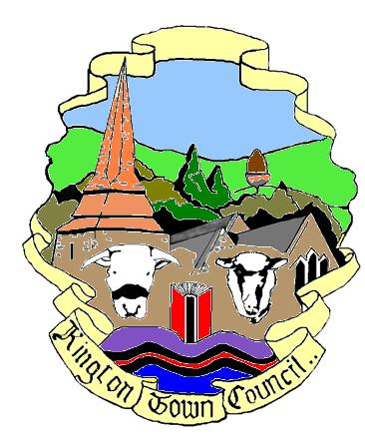
Kington Town Council
The Old Police Station, Market Hall Street, Kington HR5 3DP
Telephone 01544 239098 Mobile: 07483 914 485
email: clerk@kingtontowncouncil.gov.uk

Minutes of the Town Council Meeting held on
Monday 17th January 2022 at the Old Police Station, Market Hall Street, Kington

MEMBERS PRESENT | IN ATTENDANCE
Cllr. R. Widdowson - Chair
Cllr. R. Banks | Liz Kelso - Clerk
Cllr. J. Cooke
Cllr. F. Hawkins | 1 member of the press
Cllr. D. Redmayne
Cllr. I. Spencer

Agenda Item | Minute
1 | 012-22 | To note apologies, declarations of interest and requests for dispensation
 |  | Apologies were noted from Cllrs. E. Banks, T. Bounds, P. Edwards, & R. MacCurrach. There no declarations of interest and no requests for dispensation.
2 | 013-22 | Commissioning a Festivals Logo
 |  | Members noted a recommendation from the Festivals Working Group with regard to the commissioning of a logo to be used to promote festivals, events and other activities in Kington. Several options have been identified and were presented. After some discussion, it was agreed that the proposal by Wayne Summers Design identified as Proposal 1 in the submission and based upon the monkey puzzle trees on Hergest Ridge be accepted at a one off cost of £350.00.
 |  | There being no further business, the meeting was declared closed.

