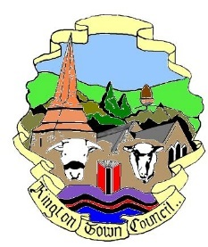
Kington Town Council

Email: clerk@kingtontowncouncil.gov.uk
Web site: www.kingtontowncouncil.gov.uk

Minutes of the Services Committee Meeting
Scheduled for Monday 21st February 2022
at the Old Police Station, Market Hall Street, Kington

PRESENT | IN ATTENDANCE
Cllr. R. Widdowson (Chair) | Liz Kelso – Town Clerk
Cllr. E. Banks
Cllr. F. Hawkins
Cllr. D. Redmayne

MEETING INQUORATE

