Kington Town Council
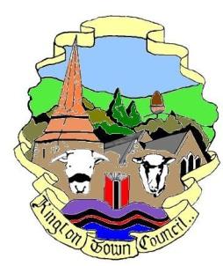

Email: clerk@kingtontowncouncil.gov.uk
Web site: www.kingtontowncouncil.gov.uk

Minutes of the Environment Committee Meeting

held on Monday 21st March 2022
at the Old Police Station, Market Hall Street, Kington

PRESENT | In attendance
Cllr. J. Cooke - Chair | Liz Kelso – Town Clerk
Cllr. E. Banks
Cllr. D. Redmayne
Cllr. I Spencer

MEETING INQUORATE

