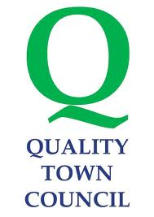

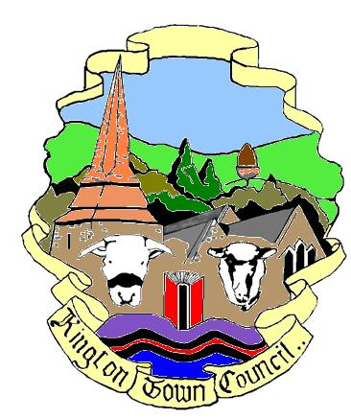
Kington Town Council

The Old Police Station, Market Hall Street, Kington, HR5 3DP
Telephone 01544 239098 email: clerk@kingtontowncouncil.gov.uk

File note: Finance & General Purposes Committee Meeting
Monday 8th January 2018 at 2.00 pm in The Old Police Station.

The Finance and General Purposes Committee Meeting scheduled for Monday 8th January 2018 was cancelled due to being inquorate.

Liz Kelso
Town Clerk
8.1.2018

Liz Kelso
Clerk, Responsible Financial Officer
Kington Town Council

