West Mercia Police
Safer Neighbourhood Team (SNT)
kw.snt@westmercia.pnn.police.uk
May 2017

About your team:

Safer Neighbourhood Teams work with local people and partners to identify, tackle and solve issues that matter to the community where you live.

Making neighbourhoods safer by cutting day to day crime and anti-social behaviour is at the heart of keeping people in West Mercia safe. Thanks to an investment in mobile tablet style computers, these will enable officers to spend more time on patrol on the street and in neighbourhoods.

Officers will continue to come to people when they need them and provide a high quality service however you contact us - in person (on the street, at community bases and at partners and communities together [PACT] meetings), on the phone or online.

Where we work:
Kington and Weobley SNT is based at Kington Police Station, Churchill Rd, KINGTON
We work around the areas of:
Almeley, Brilley, Birley, Dilwyn, Eardisley, Eardisland, Huntington, Kington, Kinnersley,
Knill, Letton, Lyonshall, Monkland, Monnington, Nash, Norton Canon, Pembridge, Rodd,
Sarnsfield, Shobdon, Staunton-on-Arrow, Staunton-on-Wye, Stretford, Titley, Upper Hill,
Weobley, Winforton, Willersley, Whitney-on-Wye,

Get in touch
 101 to talk to your local SNT or report a crime.
 kw.snt@westmercia.pnn.police.uk
✓ www.westmercia.police.uk

/ @NHfdShireCops
Only call 999 in an emergency, when a crime is in progress or life is in danger.

Your team:
PC 3911 Jo ELLIS
Mobile 07977 098394

PCSO 6115 Dick ALLFORD
Mobile 07968 462523

PCSO 40067 David BODEN

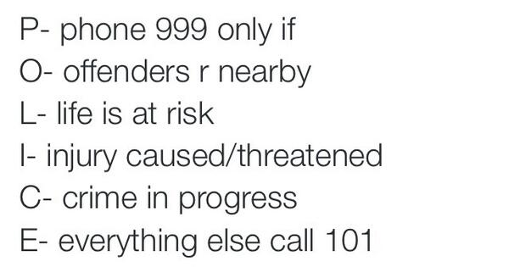
Please do not report crime via your local safer neighbourhood teams mobile phones.

PACT SURGERIES :
Thursday 8th June 2017
Weobley Shop
9.30am -10.30am

Pembridge Shop
11.00am – 11.30am

Eardisley Shop
12.00pm – 12.30pm

Lyonshall
George Car Park
2.30pm – 3.00pm

Eardisland shop
3.30pm – 4.00pm

Attachment contains further pact surgery dates.

Shobdon Pact Surgery held in Shodon post office and stores:

Saturday 3rd June 2017-
09.30-10.30am

Kington Town PACT Surgery held at the Livestock Market..

Thursday 18th May 2017
11am till 12:00pm

Your Safer Neighbourhood Team is holding FREE Overt Property Marking events.
Bring all your power tools, hand tools and pedal cycles to
Shobdon Shop.

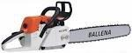
is los or stolen.

For March/April our Priority is:

You said your priority was: | Anti social behaviour in Weobley.
Date set: | March 2017
We undertook : | *High visibility patrols  *Request the community to keep reporting  *Deal robustly with youths involved  *Prosecute for any offences.  The SNT are still actively patrolling the Weobley area, although the offences have greatly reduced. An Arson was reported and enquires are still continuing with a hopeful positive result.
News/Appeals:

2 People have been arrested for shoplifting.

1 Person arrested for handling stolen goods.

1 Person arrested for handling stolen goods.

1 Person reported to court for being in charge of a dog dangerously out of control.

1 male arrested for assault and racially aggravated comments. This is something the police treat very serious and do not tolerate.

Weobley
Arson

Between 22:00 -22:10 on Saturday 22nd April 2017 the fire service were called to the Football Club in Weobley whereby the Pavilion was set on fire causing devastating damage. The fire service has deemed the fire to be malicious and deliberate. Police are currently investigating.

Eardisland
Theft

Between 09:00 and 16:00 on Tuesday 25th April 2017 poultry were stolen from a secure pen in Broom lane area of Eardisland. A dark blue vehicle was seen leaving the area.

Kington Town

Burglary Non- Dwelling

Between 14:00 and 14:30 on Wednesday 5th April 2017 a quantity of power tools including STIHL head trimmers and chainsaws were stolen from a storage shed in the Hergest Croft area of Kington.

Scam/ Crime Prevention advice

Scams
A local company was scammed out of a large amount of money by the following means…
1. They had an email from a company to say they had changed their bank account – which turned out to be true.
2. They rang the company to check and they said – yes – that is true.
3. They then paid the outstanding debt but it didn’t go to the company for whom it was intended.
4. They chased it and somehow it had disappeared.
5. It turned out that the email to the customers to explain that their bank details had changed had been intercepted and the company bank details had been changed to the bank of the scammers!!!

Crime reduction tips - Outbuildings
Garages and sheds are vulnerable to burglary, as they are generally quite flimsy structures, but they should not be forgotten. They are often the first places that a burglar will target, because they provide a ready source of tools and implements for breaking into the main house.
Garages and sheds also have lawnmowers, bikes and other valuables that are easy to steal and costly to replace. By fitting additional security to garages and sheds, burglars will find it more difficult to break in and they will have to make more noise doing so. A few simple security measures can increase the visual deterrent and reduce the likelihood of garages and sheds being targeted.
Garages and Sheds are often the first places a burglar will target
- metal up-and-over garage doors can be secured with additional purpose made locks fitted to either side, approximately 300mm up from the floor, to reduce the leverage points
- an external floor mounted, solid steel locking 'T' bar with a closed shackle padlock, will offer a good visual deterrent and make it difficult to force the door open
- wooden garage double doors can be secured with two substantial hasps and staples and closed shackle padlocks, one towards the top and one towards the bottom.
- garage side or rear doors can be secured with British Standard 5-lever mortice locks and two internal mortice rack bolts, one towards the top and one towards the bottom to reduce the leverage points
- shed doors can be secured with two substantial hasps and staples and two closed shackle padlocks on the outside, one towards the top and one towards the bottom. External hinge screws should be replaced with one-way clutch head screws to prevent them being removed and access gained this way
- garage and shed windows can be secured with internal diamond mesh grilles, which provide a good visual deterrent to opportunistic burglaries
- garden tools and ladders should be secured by wrapping a substantial chain around them and padlocking them to an eyebolt which has been secured to the floor or wall. This will prevent them being stolen or used to break into the house
- tools and garden implements should be visibly property marked with the postcode and house name or number, to deter theft and assist police with identifying the rightful owner

We have plenty of leaflets/booklets/signage to help you protect your property, please get in touch if you would like some.

