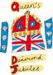

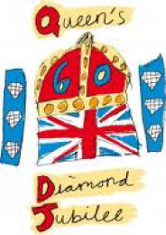

Kington
at
Herefordshire Diamond Day
11 July 2012
King George V Playing Fields Hereford
Kington Marquee depicted the themes
Community
Business and Commerce
Creative Arts
Education
Farming
Tourism
Sustainability

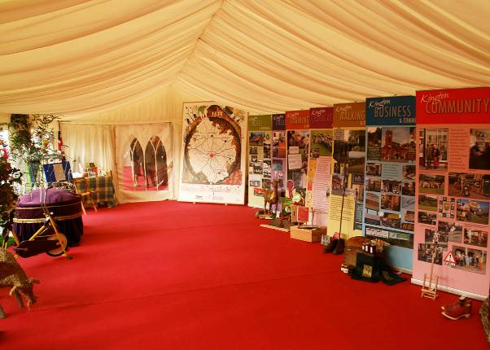

Banners designed by Margaret Roberts and Nicholas Ede.
Funded from the Kington and District Community Shop
run by Rita and Ronald Langford
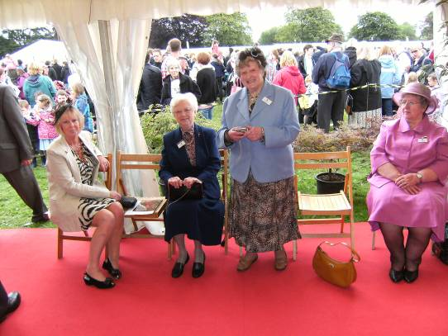

Waiting for the Queen ...
Pam Peek, Anne Edwards, Mary Whittall and Irene Phillips

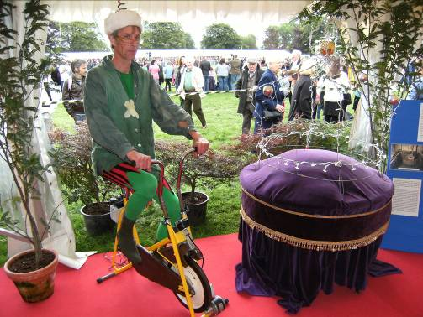

Richard Cotterill uses pedal power to light up the crown.
The crown was made by Celia Kibblewhite

Those presented to the Queen

Robert Widdowson Councillor and Mayor of Kington
Christine Forrester Councillor and Mayoress of Kington

Ken Reeves MBE & Retiring curators of Kington Museum
Sue Reeves after 14 years

Rita Langford Community and District Charity Shop
Civic Award Winner 2007

Bernard Ray Chairman of Chamber of Trade
Civic Award Winner 2012

Ann Edwards Kington Tourist Information Centre
Civic Award Winner 2005
Received the Diamond Day Award
for Tourism

Mary Whittall Civic Award Winner 2004

Pam Peek Christmas Fair Organiser

Dennis & Irene Phillips Civic Award Winner 2008

Mme Jacqueline Maigret Mayor of Marines, Val d'Oise

Mr & Mrs Ronald Bithell Diamond Wedding Anniversary couple

Nicholas Dinsdale Lady Hawkins' School (Head of History)

Kathryn Phillilps Lady Hawkins' School (pupil)

Malachy Grogan Lady Hawkins' School (pupil)

Thalia Morgan Kington Primary School (pupil)

William Hurst Kington Primary School (pupil)

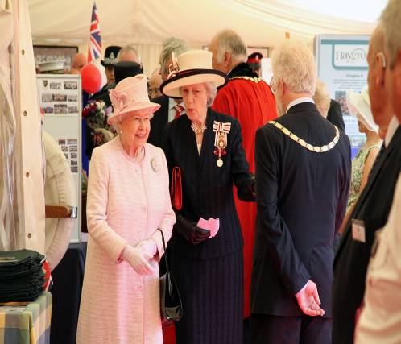

Lady Darnley introduces The Queen to Mayor Robert Widdowson

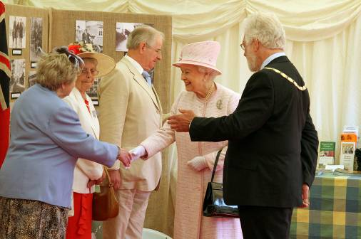

Mayor Robert Widdowson introduces the Queen to
(left to right) Mary Whittall, Sue Reeves and Ken Reeves
In attendance in Marquee during Queen's presence:

Malcolm Price First Responder
Civic Award Winner 2006
Phillip Eggerton Kington Fire Service
Civic Award Winner 2009 (Bonfire Committee)
Mark Jones Kington Fire Service
Civic Award Winner 2009 (Bonfire Committee)
Richard Cotterill Community volunteer
Civic Award Winner 2012
Steven Hodges Civic Award Winner 2010
Celia Kibblewhite Sustainability Representative
Roger Maigret Husband of Mayor of Marines

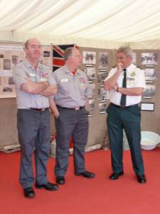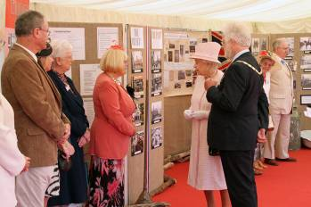

Above left: Mark Jones, Phillip Eggerton and Malcolm Price.
Above right: Bernard Ray, Pam Peek, Ann Edwards and Rita Langford meet the Queen

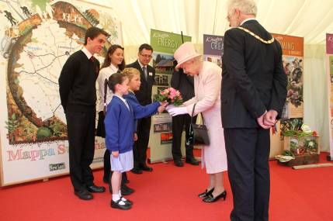
William and Thalia present a pink bouquet to The Queen which happened to match her outfit!
From back left to right: Malachy Grogan, Kathryn Phillips Nicholas Dinsdale, Thalia Morgan and William Hurst with the Mayor looking on.

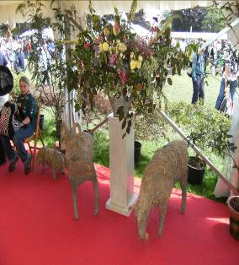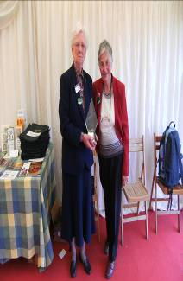
Left: Wicker goat sculptures made by Celia Kibblewhite; flower display by Caroline Ede. Right: Ann Edwards with Maureen Wright of the Tourist Information Centre.
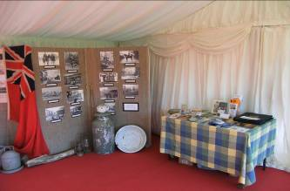
Left: Photographs of old Kington from the Museum. Lady Hawkins's School Red Ensign: the school has special permission from the Royal Navy to fly the Red Ensign on its Foundress Day,
The Kington Marquee display at Diamond Day was made possible
with the many people in Kington who gave their time freely to help
in many ways.

Diamond Day volunteers:

Jeremy Atkinson, Lawrence and Elizabeth Banks of Hergest Gardens Karen Bennett, Thomas Bounds, Ros Bradbury, Geoffrey Cooper, Richard Cotterill, Nicholas Dinsdale, David East, Caroline Ede, Nicholas Ede, Ann Edwards, Phillip Eggerton, Christine Forrester, Judith Gardner, Gary House, Peter Horrocks, Celia Kibblewhite, Kington Museum, Kington Police, Kington Primary School, Lady Hawkins's School, Harvey Jones, Rita and Ron Langford, Ian Laurie, Stephen Lloyd, Marches Access Point, Sally's Pantry, Martin Peek, Anne Phillips, Emma Phillips, Robert Price, Bernard Ray, Julia Reid, Margaret Roberts, Nick Sherwood and Transistion Herefordshire for the loan of the Mappa Sustainability, Jennifer Stephenson, Janet Thomas, Mary Tolhurst, Martin Turner, Robert Widdowson, Helen Yeomans and the people of Kington

